**Objectives**

* Demonstrate creation of Spring Boot Application
  + Spring initializr, https://start.spring.io, @SpringBootApplication, SpringApplication.run()
    - Ref - https://start.spring.io
* Explain the need and benefits of Spring Boot
  + Makes Java development easy, avoids tedious development steps, reduces development time, avoids writing boilerplate code, provides embedded tomcat server, avoid XML configuration
    - Ref - https://www.journaldev.com/7969/spring-boot-tutorial
* Demonstrate loading bean from spring configuration file
  + Spring configuration xml, spring xml schema spring-beans.xsd, <bean>, id, class, <constructor-arg>, <property>, name, value, ClassPathXmlApplicationContext, ApplicationContext, context.getBean(), singleton scope, prototype scope
    - Ref - https://docs.spring.io/spring-framework/docs/current/spring-framework-reference/core.html
    - IoC Container - https://docs.spring.io/spring-framework/docs/current/spring-framework-reference/core.html#beans
    - Scopes - https://docs.spring.io/spring-framework/docs/current/spring-framework-reference/core.html#beans-factory-scopes
    - Constructor Injection - https://docs.spring.io/spring-framework/docs/current/spring-framework-reference/core.html#beans-constructor-injection
    - Setter method injection - https://docs.spring.io/spring-framework/docs/current/spring-framework-reference/core.html#beans-setter-injection
* Demonstrate inclusion of logging in Spring Boot Application
  + application.properties, logging.level, logging.pattern, server.port, LoggerFactory, Logger, log levels (trace, debug, info, warn, error)
    - Ref - https://docs.spring.io/spring-boot/docs/current/reference/html/boot-features-logging.html

**Hands on 1**

**Create a Spring Web Project using Maven**   
  
**CODE**:

package com.cognizant.spring_learn;  
  
import org.slf4j.Logger;  
import org.slf4j.LoggerFactory;  
import org.springframework.boot.SpringApplication;  
import org.springframework.boot.autoconfigure.SpringBootApplication;  
  
  
@SpringBootApplication  
public class SpringLearnApplication {  
 private static final Logger *LOGGER* = LoggerFactory.*getLogger*(SpringLearnApplication.class);  
  
 public static void main(String[] args) {  
 *LOGGER*.info("START");  
 SpringApplication.*run*(SpringLearnApplication.class, args);  
 *LOGGER*.info("END");  
 }  
}

**OUTPUT**:

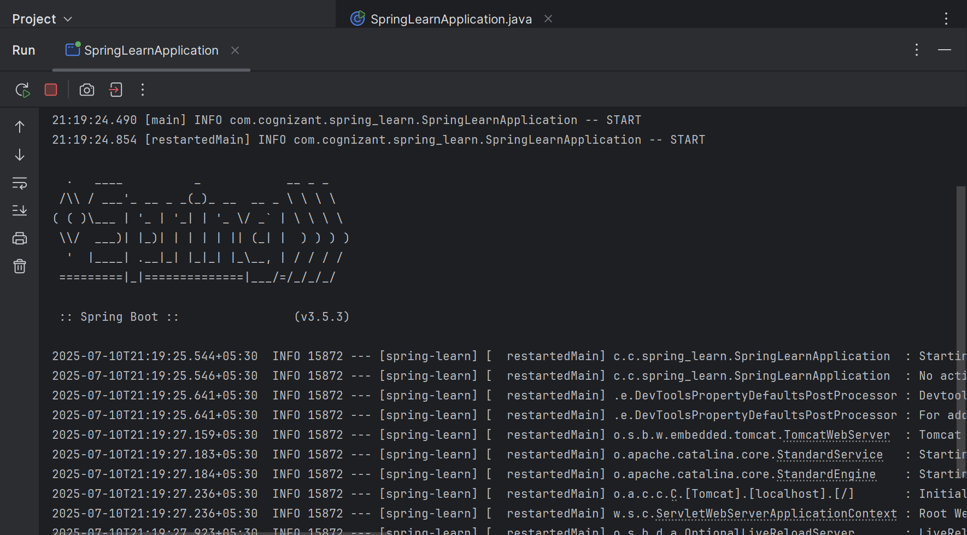

**Hands on 4**

**Spring Core – Load Country from Spring Configuration XML   
  
CODE:**

package com.cognizant.springlearn;  
  
import org.slf4j.Logger;  
import org.slf4j.LoggerFactory;  
  
public class Country {  
 private static final Logger *LOGGER* = LoggerFactory.*getLogger*(Country.class);  
  
 private String code;  
 private String name;  
  
 public Country() {  
 *LOGGER*.debug("Inside Country Constructor.");  
 }  
  
 public String getCode() {  
 *LOGGER*.debug("Inside getCode()");  
 return code;  
 }  
  
 public void setCode(String code) {  
 *LOGGER*.debug("Inside setCode()");  
 this.code = code;  
 }  
  
 public String getName() {  
 *LOGGER*.debug("Inside getName()");  
 return name;  
 }  
  
 public void setName(String name) {  
 *LOGGER*.debug("Inside setName()");  
 this.name = name;  
 }  
  
 @Override  
 public String toString() {  
 return "Country [code=" + code + ", name=" + name + "]";  
 }  
}

**country.xml:**

<?xml version="1.0" encoding="UTF-8"?>  
<beans xmlns="http://www.springframework.org/schema/beans"  
 xmlns:xsi="http://www.w3.org/2001/XMLSchema-instance"  
 xsi:schemaLocation="  
 http://www.springframework.org/schema/beans  
 http://www.springframework.org/schema/beans/spring-beans.xsd">  
  
 <bean id="country" class="com.cognizant.springlearn.Country">  
 <property name="code" value="IN" />  
 <property name="name" value="India" />  
 </bean>  
  
</beans>

**Main file:**

package com.cognizant.springlearn;  
  
import org.slf4j.Logger;  
import org.slf4j.LoggerFactory;  
import org.springframework.boot.SpringApplication;  
import org.springframework.boot.autoconfigure.SpringBootApplication;  
import org.springframework.context.ApplicationContext;  
import org.springframework.context.support.ClassPathXmlApplicationContext;  
  
  
@SpringBootApplication  
public class SpringLearnApplication {  
 private static final Logger *LOGGER* = LoggerFactory.*getLogger*(SpringLearnApplication.class);  
  
 public static void main(String[] args) {  
 *LOGGER*.info("START");  
  
 SpringApplication.*run*(SpringLearnApplication.class, args);  
 *displayCountry*();  
  
 *LOGGER*.info("END");  
 }  
  
 public static void displayCountry() {  
 ApplicationContext context = new ClassPathXmlApplicationContext("country.xml");  
 Country country = context.getBean("country", Country.class);  
 *LOGGER*.debug("Country : {}", country.toString());  
 }  
}

**OUTPUT:**

